**Chapter 7: MLOs Extraction Out of PPT-based Video Lectures without Associated PPT File**

## Introduction

As described in Chapter 4, recall that for extracting the MLOs out of a video lecture without associated PPT File, the PPT presentation slides are, first, extracted using the “Smart PPT Extractor” component that takes the video lecture as input to extract the presentation slides and then generates the PPT Presentation file. The PPT File is then converted to the Reference PPT Template, then the PPT Reference MLOs are extracted by the “Reference PPT Learning Objects Extractor”. The PPT Reference MLOs are then used by the “Non-Reference PPT Learning Objects Extractor” with the created PPT file to extract the corresponding PPT MLOs. Both extracted PPT MLOs and a video lecture are then fed to the “Video Lecture Learning Objects Extractor” component, to extract the different video lecture MLOs. The details of the implementation algorithm are described in more details in the following sections.

## 7.2 Extracting Presentation Slides from Video Lectures

This section presents in the details of the process of extracting the presentation slides from video lectures. A summary of the whole process is shown in Figure 24. The video lecture is fed to the first component (**Preprocessing**) which extract and eliminate duplicate frames, resulting a unique frame. The extracted unique frames are then fed to second component (**Video Frames Classification**) which classify input frames into Slide and Non-Side frames, all non-Slide frames are neglected, resulting only slide frames. The slide frames are then fed to the third component (**Slide Type Identification**) to classify the slide frames into (Cover, Agenda, Separator and Explanation) resulting frames with their types. Classified frames are then fed to the fourth component (**Slide Content Identification**) to Identify both the title and the contents of each slide frame. Classified frames are with their content are then fed to the fifth component (**Slide Text Extraction**) to extract text from the identified slides parts (title and content), resulting classified slides with their extracted titles and content.

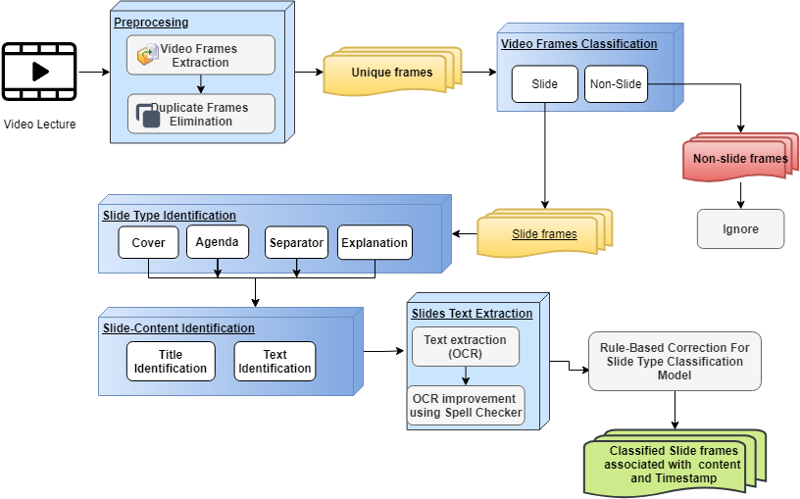

**Figure 24**: The Process of Extracting Presentation Slides from Video Lecture

### 7.2.1 The Lecture Video Frame Preprocessing

The lecture video preprocessing phase consists of two components as shown in Figure 25. The first component, the Video Frames Extractor (1) extracts the video frames using Open CV library [54]. Similar slides in lecture video usually last for few seconds to minutes, so, only one frame per second (FPs) is considered to minimize the count of extracted video frames. Accordingly, duplicate consecutive frames are eliminated by the second component, the Duplicate Frames Eliminator (2), by computing frame-to-frame Similarity [55].



**Figure 25**: Unique Video Frames Extraction from Video Lecture

### 7.2.2 The Video Frame Classification

The lecture video might contain slide frames and non-slide frames, to distinguish between video frames and eliminate non-slide frames, a Convolutional Neural Network (CNN) [44] architecture is employed. Figure 26 shows the process of training the Video frame classification model. It starts with data pre-processing phase which is responsible of normalize, shuffle, and resize input images, followed by splitting input data into train and test data then training the model with training data, finally evaluating model with different evaluation metrics.

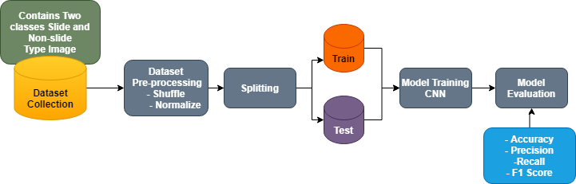

**Figure 26**: Process of Training and Evaluating Video Frames Classification CNN Model.

#### 7.2.2.1 the Slide and Non-Slide Dataset

To train and evaluate the CNN classifier, we have built a dataset which consists of colorized images with total number of 100000 images divided into 50000 slide frames and 50000 non-slide frames. All slide frames are selected from Dataset: Slideshare-1M provided by Stanford University [61]. For non-slide frames additional 50000 images are selected from Open Images dataset provided by Google Inc [62]. A Sample of slide and non-slide images are shown in Figure 27 and Figure 28, respectively.



**Figure 27:** Sample of Non-slide Images.

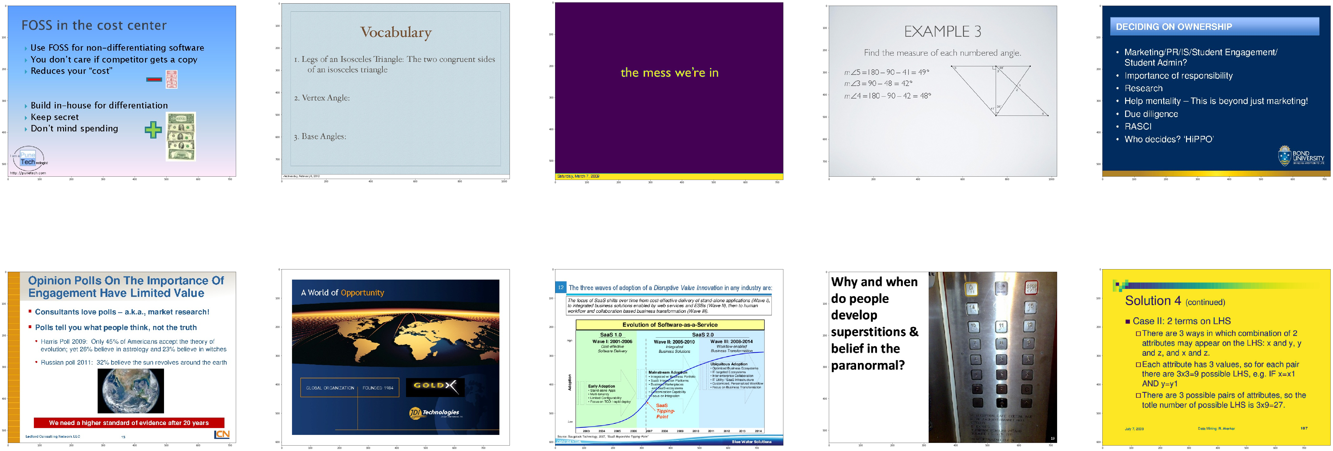

**Figure 28**: Sample of Slide Images.

#### 7.2.2.2 Building the Slide/Non-Slide CNN Deep Learning Model

Our proposed CNN model for classifying video frames into slide and non-slide is shown in Figure 29. It is composed of 8 layers, 3 convolution layers, 3 max pooling layers and two fully connected (Dense) layer. In our model, the ReLU [63] activation function is used because it solves saturation and gradient problems and is much faster than traditional activation functions such as the sigmoid activation function. To prevent overfitting, we introduced a dropout layer to each hidden layer. It has been shown that the dropout approach dramatically decreases overfitting and improves the neural network efficiency [64]. The model is fit using the efficient Adam version of stochastic gradient [65]. Figure 28 is drawn using visualkeras [66] python library.